# Introduction

Making sure all data is consistently formatted and all stored in the same location can be difficult, especially in the case of tutors. They already have several options with positives and negatives, you can’t beat the convenience of just taking attendance on a piece of paper, but this can be easily lost and needs to be digitised later. Then there is just putting attendance straight into mylo but with its less-than-ideal UI, but consistent formatting and having all the data in one location is a big upside. So, with this in mind I was given the daunting and perilous task of creating a mobile app prototype with the convenience of paper and the data storage of mylo.

So, now we know why I was given this very dangerous task, but what does it actually have to do? Well, we have to be able to store information about students and be able to add and delete said students.

# Usability Goals and Design Principles

To give some context, this prototype was designed with Don Norman Design Principles in mind which are: Visibility – the more the user can see, the more likely they are to be able to successfully navigate the app.

Feedback – make sure the user can tell what the app is doing an every point, don’t leave a user wondering if they pressed a button or not

Affordance – use design elements that give users an inherent knowledge of what something does.

Mapping – make controls have a visible relation to what they actually do.

Constraints – set limits for the user to not confuse and overwhelm.

Consistency – Design the app so that parts of the app that do similar things use similar design elements

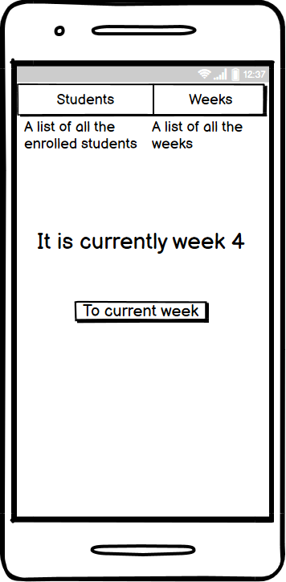(Amiana, 2020)(MapInTime 2021). It was also made with he following design goals in mind: Learnable on first use, Memorable on repeat uses, Efficient, Failure-resistant, Forgiving and Satisfying (Wells, 2021). With this prototype I had a large focus on efficiency, trying to make the users use as little clicks as possible in the most common use cases. This can be seen on the bootup screen of the prototype below. Seeing as the most common use case would be adding grades in the current week, I added a button on this main screen to accommodate for this common use case. As can also been seen in this screenshot is the top bar on this screen that appears on every screen. On this screen they have been given descriptors to help first time users figure what they do and where they take you. These buttons are also useful for if a user gets lost in the app these buttons bring them, back to a known screen.

The next example we have of design principles and goals is the student list and week list screens picture on the right these are updated after the first round of user testing. I added feedback to make sure the knew that the app was exporting after pressing the button 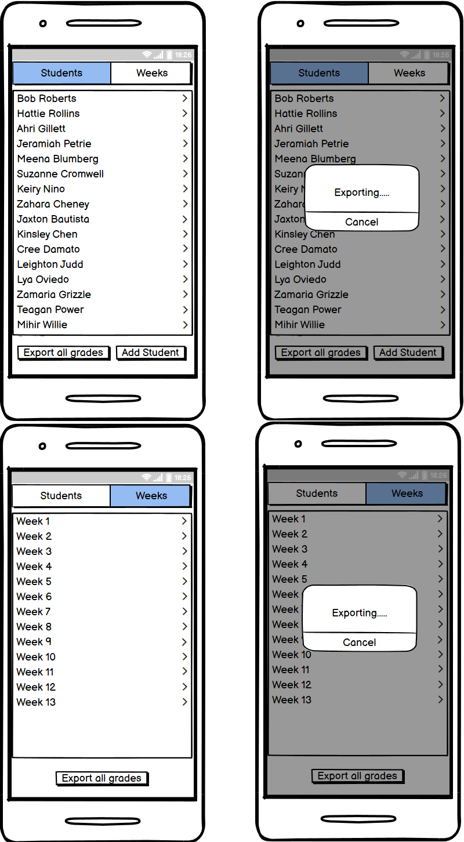instead of leaving them to question if it worked or not. I also made sure to make all clickable list consistently designed as can be seen in these screen shots as well as adding the arrows top the right to make sure users know that the lists are clickable which was an identified problem in the user testing.

Figure 1 Main Screen

Throughout the prototype I’ve tried to keep as many options on the screen as possible with clear labels without making it look cluttered or overwhelming to enhance the visibility for the user so all their options can be seen, and it is clear what each one does.

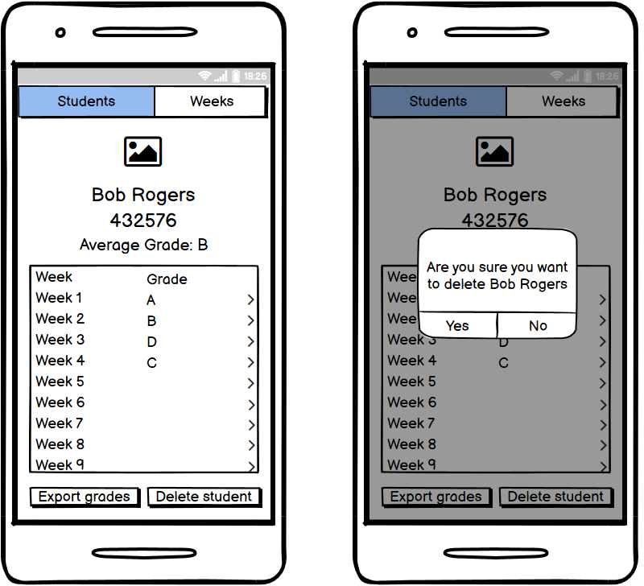

On the student’s page after the user feedback, I updated the list of the students grades to give it more consistency with the other lists. I also added some failure-resistance in the form of a alert popup to make sure the user is certain about deleting a student.

# Testing Methodology

For gathering users, I predominately just asked close friends who had time available. This introduced several biases straight away as the users would be bias towards the design knowing that I made it, making them potentially speak more favourably of the design. Also, none of these users were tutors so that is another issue with this user set, they are not accurate to the actual user base the app is designed for and as a result, they would potentially have no reference point of similar solutions or the actual use cases of this app. The users were also all aged 20 to 22 and almost all attended university, this highlights a bit of a lack of diversity as all the users were fairly tech literate people from maybe slightly higher than average socioeconomic standing.

For user testing I used remote talk aloud testing over Discord that I recorded with OBS after getting the user’s consent. This was due to covid safety and the convenience and easy recordability of the tests. I first ran the users through what the app was and what it would be used for, then I explained that we would be doing talk aloud testing and what that entailed. After this I ran the users through the test tasks, these test tasks were:

T1: Bob Roberts has been accidently added to the class instead of Robert Bobs, remove Bob and add Robert instead.

T2: Bob Roberts is bragging about getting an A in week 3, find his grade to see if he deserves to brag or not.

T3: All the tutors are having a bet on which tutorial got the best average mark in week 4, find your average for that week to see if you should bother to participate.

T4: Week four has been configured incorrectly, change it to use a score instead of a grade.

T5: You've just finished the week 4 tutorial, give Bob Roberts his grade of a B.

These test tasks were to check if the app meet the following success requirements:

R1: Remove a student.

R2: Add a student.

R3: Add a grade to a student.

R4: Students have an ID and name.

R5: Summary of marks each week.

R6: Summary of marks for each student

These requirements and test lead to the tasks matrix that is figure 1 in the appendix.

To round things off I ask each user if they had any final thoughts to gather any last-minute feedback and get their overall thoughts of the prototype.

During this user testing I gathered both qualitative and quantitative data in the form of feedback from the users and noting where mistakes were made for qualitative data, and for quantitative I took timings from the recording for how long it took each user to finish each task. This data can be potentially used to make comparisons to future revisions of the prototype and app to get a rough idea of if the improves have made the app more useable and/or efficient. Ideally for good quantitative data I would need many more users to test to smooth over the data and find a more realistic averages from the data, I would also most likely need to run separate user test to get truly accurate timing data so that I could not do talk aloud testing as this will most likely add more time to the test as the users might spend more time trying to articulate what they think (Budiu, 2017).

# Testing Results and Discussion

Overall, the user feedback and testing went very well. There was one reoccurring piece of feedback that I got from all the users that was it was not obvious that the lists of student’s grades on the student page and the list of students and their grade on the week page were clickable, most of the users were not confidant it could be clicked on and even in the case of user 4 in task 5, they didn’t even think to click on the list, so to help with this I added arrows at the edge of each item in the list to indicate that a listed item is clickable similarly to how Reddit does in it’s settings app, as seen below.

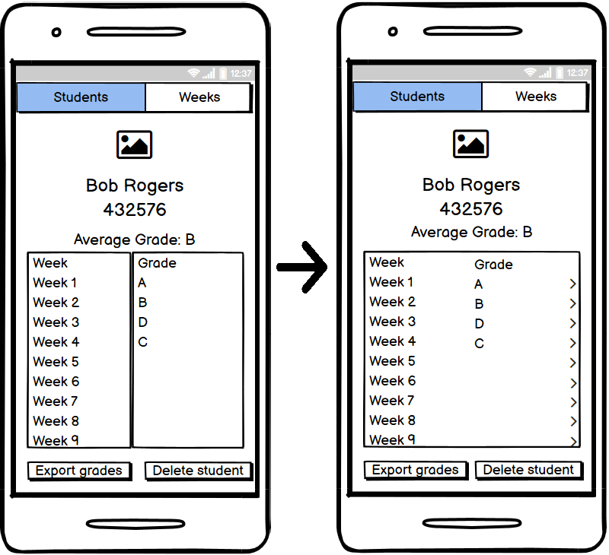

Figure 2 Student Page Changes

I also made all the list have consistent styling to further help show that all the lists are clickable as the students list had a different style to all the other lists which may have contributed to users thinking the other lists weren’t clickable. Also, during user testing I noticed the student delete was not very failure-resistant and added an alert popup to confirm you wanted to delete the selected student. In a similar vain I also added alerts for when grades are being exported to give more feedback and clearly tell the user what the app is currently doing.

Overall, the test times that I gathered look to be promising. Every test aside from the first test was completed in under 30 seconds on average, which seems to imply the focus on efficiency when designing the app has paid off. The longer amount of time on the first test is most likely due to multiple factors, for one it is the first test thus the first time the user has seen and used the app, this itself will lead to extra time as the user visits all the pages in this test for the first time so they have no idea what no expect or where buttons will be. Another factor could be that this is the only task that asks the user to do more than one task, the user has to add and delete a user, so this would lead to the longer time as well.

# Conclusion

Having survived my perilous task of sitting at my computer, drawing some things and then talking to people, we have discussed my testing methodology and user recruiting, and discussed biases and flaws in both and have completed a prototype with one user feedback and revision cycle. The prototype has been improved based o feedback gathered from the users with more consistent design, more visibility in the form of more obvious buttons and failure resistance in the form of second prompts when deleting, and we’ve gotten useful user data that can be compared against in future revisions or implementations of this prototype.

# References

Budiu, R., 2017. *Quantitative vs. Qualitative Usability Testing*. [online] Nielsen Norman Group. Available at: https://www.nngroup.com/articles/quant-vs-qual/ [Accessed 17 March 2021].

Amiana, D. (2020). *General principles of design — Don Norman’s principles*. [online] Medium. Available at: <https://uxdesign.cc/general-principles-of-design-don-normans-principles-4e2d97267905> [Accessed 19 March 2021].

Wells, L. (2021). *Week 1: Intro, Prototyping, User-Centered Design.* [online] Mylo. Available at: <https://mylo.utas.edu.au/d2l/le/content/434620/viewContent/3902784/View> [Accessed 19 March 2021].

MapInTime. (2013). *Don Norman’s Design Principles*. [online] Available at: https://williamgrimes12.wordpress.com/2013/01/22/don-normans-design-principles/ [Accessed 19 Mar. 2021].

‌

# Appendices

|  |  |  |  |  |  |  |  |
| --- | --- | --- | --- | --- | --- | --- | --- |
| Tasks Matrix | | | | | | | |
| Requirements | | | | | | | |
| Tasks |  | R1 | R2 | R3 | R4 | R5 | R6 |
| T1 | x | x |  | x |  |  |
| T2 |  |  |  |  |  | x |
| T3 |  |  |  |  | x |  |
| T4 |  |  |  |  |  |  |
| T5 |  |  | x |  |  |  |

Figure 1

|  |  |  |  |  |  |
| --- | --- | --- | --- | --- | --- |
| Time Users Took to Complete Tasks in Seconds | | | | | |
|  | Task 1 | Task 2 | Task 3 | Task 4 | Task 5 |
| User 1 | 63 | 10.28 | 23.48 | 10.53 | 38.28 |
| User 2 | 30.48 | 7.77 | 20.76 | 34.04 | 32.61 |
| User 3 | 88.32 | 14.55 | 31.04 | 31.8 | 26.09 |
| User 4 | 46.67 | 27.7 | 31.39 | 30.53 | DNF |
| User 5 | 34.36 | 8.45 | 11.76 | 20.92 | 21.66 |
| Average | 52.57 | 13.75 | 23.69 | 25.56 | 29.66 |

Figure 2